TRAINER'S Must-Do's

Your Smartest Guide to Engage Your Clients Online
~~~~~~~~~~~~~~~~~~~
To engage your connections and leads consistently you need to:

- Define Your A- Game. What is the product or service you are offering like no other person can?

- Keep Your Message Simple: Simple Sells.

- Choosing Your Power Media. What is the medium you are best at, in expressing your skills? Video? Writing? Design and email? What is the media which your market prefers? You may need to survey this and find a way across between the medium they like and the medium you are great at. You can’t ignore their preferences it’s a priority and just in case it isn’t your best preferred channel you will need to get coached for this.

- Get to Heart of the Matter. Be relatable. Tackle your crowd’s biggest problems.

!!! ATTENTION: Get people’s attention.
- Ask the Hard Questions
- Offer different content
- Throw interesting ideas
- Speak elaboratively and with confidence
- Use attractive colors, layout, and designs

**Here are checklists to guide you through what you need to do for major Online Channels to get the highest engagement with your connections

Email

- Build a rock solid database. Make sure all contacts have emails that work
- Use a killer subject line.
- Tag your clients in such a way they receive contact they will need and most probably find interesting
- Send from 2-3 emails weekly to your circle
- Add video content and speak to your clients don’t just let them read.
- Make reward for engagement, such as getting a freebie or discount when they fill out a survey or web form
- Build fancy landing pages with a colorful and attractive design color schemes that will make them want to click your links

YouTube

- Use simple and Beautiful Thumbnails
- Add subtitles to your video
- Add simple explanations – as you go along especially animated
- Use high resolution images at least 1289 x720 pixels
- Create an attention grabbing and compelling title
- Use inspiring intro and outro music in the background
- Ask your audience what they want more of. This looks very simply, but a lot of people with forget to ask their audience what they want more of.

Other Social Posts

- Be Authentic In Your Content. Give your audience real value of you are an expert in. Be direct in your message and let them know what they will be getting when reading your post
- Connect with people who match your avatar. You want to connect with people who will be eventually interested to buy or at least refer your product. The more specific you can get, the better the engagement.
- Engage with simple, clear, and thoughtful comments (not just emojis).
- Host Giveaways
- Partner people who address similar audiences. That way, both of you will gain followers from each other, creating a win-win situation.

Blogs and Articles

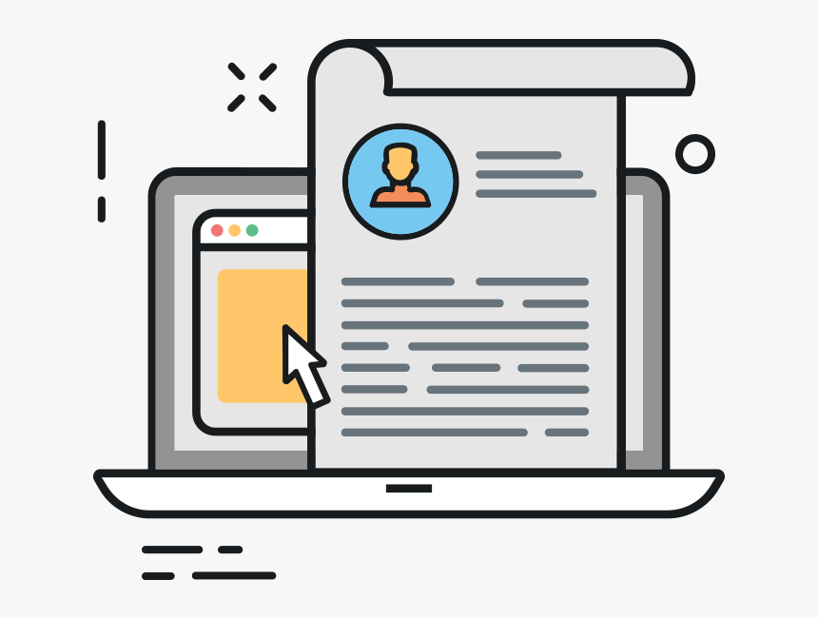 | - Make it the main focus – don’t add on any pop ups or too much adds on the side bar  - Make it about your audience interests  - Get Visual, include images or screenshot to clarify a point you are trying to bring across  - Make it easy to like or comment  - Make it easy to load  - Make it simple to share with other people  - Add some significant hyperlink to the content that will add huge value to your readers

Online Training

- Create a Course Home Page and add all required information, advice and resources.
- Link Your Home Page to a Learning Management System for your crowd to be able to access course contact with ease.
- Communicate your material using various channels: Audio, Video, email, chat, instant messaging, home page announcements and discussion forums
- Engage online learners by getting them out of their chairs (or beds) and get them involved in active learning. Ask your learner to move around and take notes or ask them to interview people working in the field, or, in any possible way bring their learning into the community where they live, for example by getting them to research for case studies or observe and analyze local data.
- Add a Twitter link to your course homepage, push posts with course-relevant content to your students using hashtags.
- Pace up with your feedback during the learning process. Giving people feedback on an assessments can also have a big impact on their engagement level so as to actually continue joining other assessments. The more detailed the feedback is, the better the commitment level you get. So stay away from faint praise or unclear messages.
- Use a Learning Management System (LMS) to give your clients a chance to measure their progress, allowing students to take more responsibility for their own learning.
- Walk your clients through their learning plan. Allow your learners to choose best path for them to complete their training requirements.

