**TRAINER'S Must-Do's**

**The Quickest Start-up Guide for *Active* Training**

**MB900295311.JPG**

|  |  |
| --- | --- |
| Topic | Page |
| General Rules You Must Know for Effective and Interactive Training | 2 |
| How to Elicit Good Questions | 3 |
| How to Setup Your Training Room | 4 |
| About Group Movement | 6 |
| Seek feedback from the 1st minute: This is GOLD | 7 |

**General Rules for Effective and Interactive Training:**

* Assess the need for training and the participants; preferably through a written TNA [(training needs analysis)](https://www.trainersbox.net/training-needs-analysis.html).
* Know your audience's background and interests before the training commences.
* Double check that all training room requirements are available.
* Set general learning goals and specify objectives for the training.
* Ask the learners what added value they would [expect](https://www.trainersbox.net/store/p1027/expectations-exercise.html.html) from this training.
* Make sure your learners know their session agenda and break times.
* Open your session with something your learners don't expect; such as a funny/dramatic story, a question, [game](https://www.trainersbox.net/store/p9/training-games.html.html) or [icebreaker](https://www.trainersbox.net/store/p10/icebreakers.html.html).
* Set participant [ground rules](https://www.trainersbox.net/participants-ground-rules.html) for the group.
* Maintain a two-way communication with your learners. If you have extra time you can add to your [activities](https://www.trainersbox.net/shop.html).
* When you feel, the learners are beginning to lose concentration; use an [icebreaker](https://www.trainersbox.net/store/p10/icebreakers.html.html) to give them a good laugh and get them back on track.
* Open the floor for group participation by pausing before you start a new idea and ask questions.

Class participation fosters learning - avoid posing questions that require one word replies like “yes" or "no". Rather encourage conversation, which leads to relationship building, information sharing and group thinking, by posing questions like this:

Why do you think it is important to…………?

What are some ways people………………….?

How would you reply to someone like that?

How do you think they would respond?

Where would you find…………………………?

Who do you think is responsible for…………?

When is the appropriate time to…………..…?

Which one would you use to………………….?

How would you address a situation like that?

How would you solve the problem?

How quickly should we reply?

* At the end of every session quickly go over the main ideas discussed.
* Before you close, announce the main topics that are about to be covered in the following session.

**Elicit Good Questions:**

* Acknowledge that questions could start early in the program; so encourage your trainees to ask questions, by thanking them or complimenting them saying things like: "Wow, you just raised an important point!" or "Excellent question, thank you!"
* Respond positively to the first question asked. Your trainees will be keeping an eye on you to observe how serious you are.
* Watch non-verbal behavior. You can often detect a desire to ask a question or challenge a statement you just made from the facial expressions or body language without waiting for someone to interrupt or raise their hand.
* Remind the group that there are no 'stupid' questions.
* Repeat or rephrase questions to show that you understood and to make sure all the other trainees have heard.
* Pause after calling out questions for about 5-10 seconds; this may seem like a long time, but it gives trainees time to answer.
* When someone asks a question, maintain eye contact and listen attentively, be aware of your body language, encourage your learner to elaborate. But as you answer, address the whole group, never just the person who asked because this could make the rest of the group feel sidelined and lose focus.
* Never ask if there are any questions immediately before scheduled coffee breaks, meal times, or dismissal times. People look forward to their breaks and start preparing to slow down, so this will inhibit questions, or make the questioner very unpopular!
* Assign times specifically for brief 'question and answer' in the training schedule. This will encourage the trainees to prepare their questions, or hold them until the right time.
* At other times, without implying that you are rushed, you could briefly answer one or two questions. Make it pleasantly clear you prefer trainees to wait for the scheduled question time.

**Training Classroom Layout Options:**

These are the recommended room setups for your training:

**For over 30 participants**

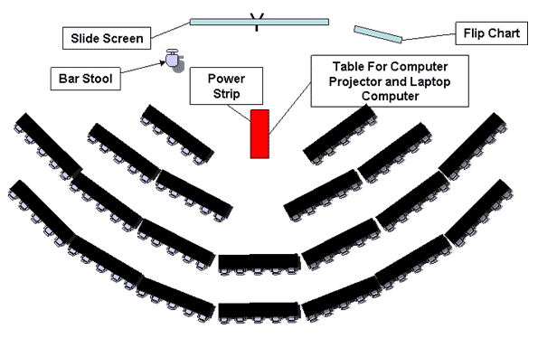

**For 13 to 29 participants:**

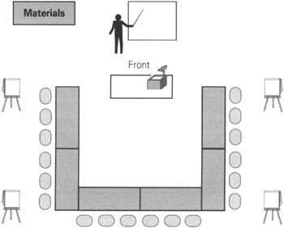

**For less than 12 participants:**

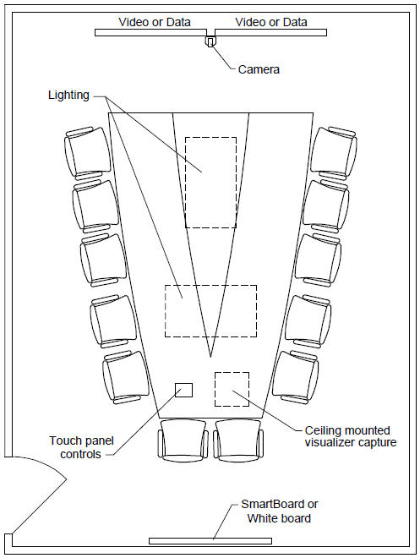

**Layout for last day of classes' ceremony for 30+ participants:** The layout below is very practical especially for handing out training attendance certificates and taking photographs.

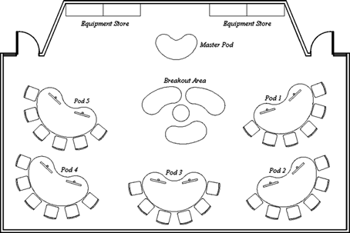

**Group Movement:**

Moving your groups around is exciting, keeps energy levels up and creates opportunities for extra interaction. Most trainees in extended seminars will probably identify a favorite seat or area and stick close to it until the end of the training. It is your role to break-up these seating patterns to the benefit of the participants. There are several ways to do this:

1. Change seating arrangements from a classroom set-up to auditoriums to semi-circular tables: this allows trainees to experience new locations and mingle with new people.
2. Alternate the size of the work groups from, say seven people to three people, and get the help of coached training assistants for larger training groups.
3. Divide and locate trainees into different physical locations according to their views and based on whether they agree or disagree on a topic. Allow 'converts' to move over to the *other* group.
4. Conduct a group activity asking each person to choose the person they know least about, or disagree with most, and partner them for 10/15 minutes of conversation.

**Training Evaluation Guidelines and References:**

[Evaluating your program](https://www.trainersbox.net/store/p940/course-evaluation-spreadsheet.html.html) as a whole and your performance are vital elements of successful training; it gives you the feedback you need to measure what was provided versus what the learners expected.

To access free, readymade templates for managing training events; [Click Here.](https://www.trainersbox.net/free-resources-634099.html)

Good luck and wishing you a fantastic training experience!

**Customer Excellence Team**

**TRAINER'S BOX**®

[**www.trainersbox.net**](http://www.trainersbox.net)